|  |
| --- |
|  |
| **Southgate Elementary IB PYP World School** |
|  |



# Upcoming Events

**January 15**

School and Central Offices Closed – MLK

**January 17 & 18**

2hr Early Dismissal.

**(@12:25**) End of Marking Period

**January 19**

School Closed for all students, semester break.

**January 26**

Mo Gaba Day

**February 6**

2hr Early Dismissal **(@12:25**); Unity Day

**February 19**

School and Central Office Closed – President’s Day

**March 19**

2hr Early Dismissal

(@ 12:25 pm); Unity Day

**March 25-29**

School and Central Offices Closed, Spring Break

**April 1**

Schools and Central Offices Closed, Spring Break

**April 4 & 5**

2hr Early Dismissal (@12:25), End of third Marking Period

**April 10**

Schools & Central Offices Closed, Eid al-Fitr

***2024***

**School Hours: 8:00-2:25 Mr. Greubel, Principal**

**Office Hours: 7:15-3:15 Ms. Tuscano, Assistant Principal**

**News at a Glance**



Happy New Year! Welcome back from an enjoyable and restful winter break. We are excited to have students return to the routine of attending school each day. Congratulations to the following classes for winning the December to Remember Attendance Challenge:

Kindergarten: Ms. Kaiser

1st Grade: Ms. Huber 4th Grade: Mrs. Simoncic

2nd Grade: Mrs. Huck 5th Grade: Ms. Huber & Ms. Cheicis

3rd Grade: Mrs. Woolley

We would like to thank the PTA for hosting our first ever Cookies with Santa Event. It was a blast celebrating the holiday season with our Southgate community. [Click here to access the SGE PTA website to learn more about upcoming meetings, events, and resources.](https://nam12.safelinks.protection.outlook.com/?url=https%3A%2F%2Fsites.google.com%2Fview%2Fsouthgatepta290%2Fhome&data=05%7C02%7CHARGUBRIGHT%40AACPS.org%7C428a192549894f3670af08dc0bbcf84b%7Cb7d27e93356b4ad88a7089c35df207c0%7C0%7C0%7C638398153455290682%7CUnknown%7CTWFpbGZsb3d8eyJWIjoiMC4wLjAwMDAiLCJQIjoiV2luMzIiLCJBTiI6Ik1haWwiLCJXVCI6Mn0%3D%7C3000%7C%7C%7C&sdata=BJZOPxupzOfK17qB9%2BLxymtxjKBLv5xuSQx6QzMhZ4E%3D&reserved=0) 

As we return to school, our Boosterthon fundraiser (The Southgate Tiger Two-Step) is planned to kick-off on January 4th. ALL students are invited! Register your student TODAY on [www.mybooster.com](https://nam12.safelinks.protection.outlook.com/?url=https%3A%2F%2Fmybooster.com%2Fv3&data=05%7C02%7CHARGUBRIGHT%40AACPS.org%7C428a192549894f3670af08dc0bbcf84b%7Cb7d27e93356b4ad88a7089c35df207c0%7C0%7C0%7C638398153455446983%7CUnknown%7CTWFpbGZsb3d8eyJWIjoiMC4wLjAwMDAiLCJQIjoiV2luMzIiLCJBTiI6Ik1haWwiLCJXVCI6Mn0%3D%7C3000%7C%7C%7C&sdata=ZDy2QwC4xoYHbfRJ%2ByL3%2Fa0s2NDXQr0SZ3WEnusX%2Flg%3D&reserved=0). They’ll earn a free gift & you’ll get access to all the fun features to share and donate toward our school goal of $17,000 for student incentives and programs, as well as recess equipment.

You can do 3 things to help support our school through this fundraiser.

1. Register on [www.mybooster.com](http://www.mybooster.com/) tonight.

2. Share about our fundraiser with family and friends using the SHARE BUTTON on [www.mybooster.com](http://www.mybooster.com/).

3. Pledge to help our school, if you are able.

We are looking forward to our winter concerts scheduled on the following dates:

Band and Chorus: January 10th at 6:00pm

Strings: January 24th at 6:00pm

Happy New Year!



Please keep our office informed as contact information changes.

It is important for student safety as well as home school communication that our school has your latest contact information. Please send in any changes in writing to the main office. Also, please keep us informed of any changes in arrangements for daycare or for after school routines.

Joke of the

Month

What are mountains favorite type of candy?



**REMINDER: STUDENTS MUST BE IN THEIR SEATS AND READY TO LEARN AT 8:00 A.M.**

**IF YOUR CHILD/CHILDREN ARE LATE, AN ADULT MUST SIGN THEM INTO THE OFFICE.**

Attention ESOL Families:

WIDA Testing will begin this month. The testing window opens January 9, 2024, and runs through February 15, 2024.

It’s very important for your child to be in attendance, well rested and ready to go.

Any questions, please reach out to your child’s ESOL teacher. [ksthomas@AACPS.org](mailto:ksthomas@AACPS.org) or [SSHIM@AACPS.org](mailto:SSHIM@AACPS.org)

For more practice at home, your child can go to the WIDA Sample Items at this link below.

[https://qr.page/g/4bWcA7QnmNQ](https://nam12.safelinks.protection.outlook.com/?url=https%3A%2F%2Fqr.page%2Fg%2F4bWcA7QnmNQ&data=05%7C02%7CHARGUBRIGHT%40AACPS.org%7Cc8ca89f34982419cf8c708dbffd9c734%7Cb7d27e93356b4ad88a7089c35df207c0%7C0%7C0%7C638385083034777548%7CUnknown%7CTWFpbGZsb3d8eyJWIjoiMC4wLjAwMDAiLCJQIjoiV2luMzIiLCJBTiI6Ik1haWwiLCJXVCI6Mn0%3D%7C3000%7C%7C%7C&sdata=UBYWDbO3uGBcRUkf9pXwImw%2B28eh9bthXuaflJvIlOk%3D&reserved=0)

Come Join PTA for our monthly meeting!

January 17, 2024

5:30-6:30 pm in the Media Center

*Southgate Lunch Schedule*

PK & K  10:00 - 10:30

1st  grade  10:35 - 11:05

2nd  grade 12:20 - 12:50

 3rd  grade 11:10 - 11:40

 4th  grade 12:55 - 1:25

 5th  grade 11:45-12:15

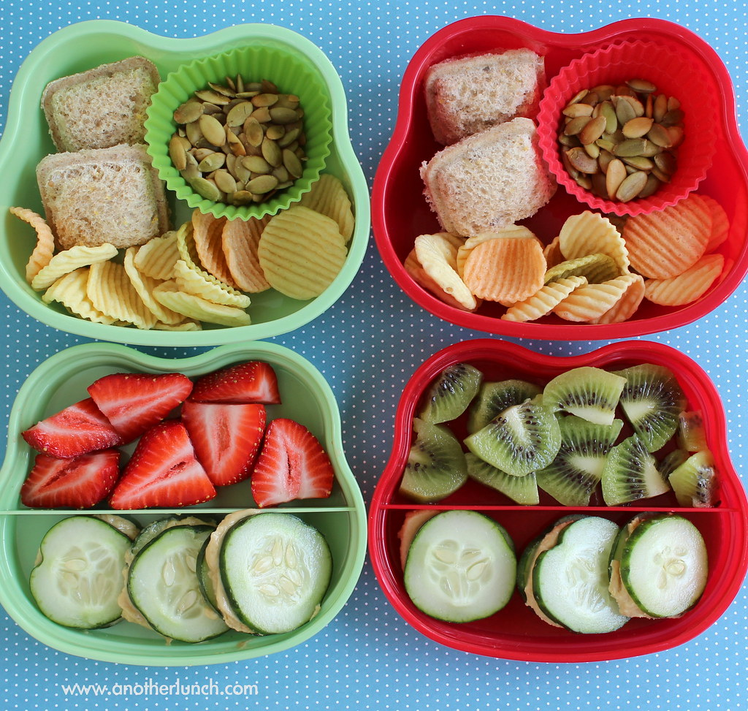

Joke of the Month Answer

Snowcaps